16.2: 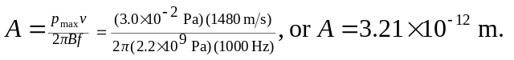The much higher bulk modulus increases both the needed pressure amplitude and the speed, but the speed is proportional to the square root of the bulk modulus. The overall effect is that for such a large bulk modulus, large pressure amplitudes are needed to produce a given displacement.

